**WEEK-3**

**Spring Core and Maven**

**Exercise 1: Configuring a Basic Spring Application**

**Code:**

**BookRepository.java:**

package com.library.repository;

public class BookRepository {

public void saveBook(String bookName) {

System.out.println("Book '" + bookName + "' has been saved to the repository.");

}

}

**BookService.java:**

package com.library.service;

import com.library.repository.BookRepository;

public class BookService {

private BookRepository bookRepository;

// Setter for dependency injection

public void setBookRepository(BookRepository bookRepository) {

this.bookRepository = bookRepository;

}

public void addBook(String bookName) {

System.out.println("Adding book: " + bookName);

bookRepository.saveBook(bookName);

}

}

**MainApp.java:**

package com.library;

import com.library.service.BookService;

import org.springframework.context.ApplicationContext;

import org.springframework.context.support.ClassPathXmlApplicationContext;

public class MainApp {

public static void main(String[] args) {

// Load Spring application context

ApplicationContext context = new ClassPathXmlApplicationContext("applicationContext.xml");

// Retrieve BookService bean

BookService bookService = (BookService) context.getBean("bookService);

bookService.addBook("Prawins Tales ");

}

}

**Output:**

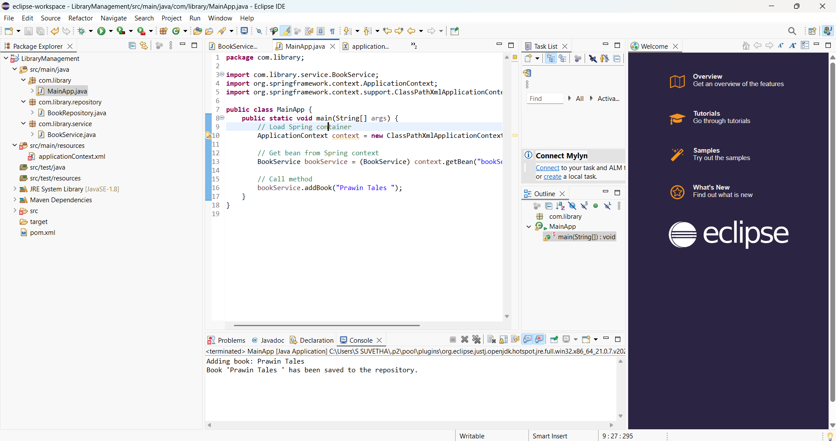

**Exercise 2: Implementing Dependency Injection**

**Code:**

**BookService.java:**

package com.library.service;

import com.library.repository.BookRepository;

public class BookService {

    private BookRepository bookRepository;

    public void setBookRepository(BookRepository bookRepository) {

        this.bookRepository = bookRepository;

    }

    public void addBook() {

        System.out.println("Adding book...");

        bookRepository.save();

    }

}

**BookRepository.java:**

package com.library.repository;

public class BookRepository {

    public void save() {

        System.out.println("Book saved to database.");

    }

}

**MainApp.java:**

package com.library;

import org.springframework.context.ApplicationContext;

import org.springframework.context.support.ClassPathXmlApplicationContext;

import com.library.service.BookService;

public class MainApp {

    public static void main(String[] args) {

        ApplicationContext context = new ClassPathXmlApplicationContext("applicationContext.xml");

        BookService bookService = context.getBean("bookService", BookService.class);

        bookService.addBook(“Clean Code”);

    }

}

**Output:**

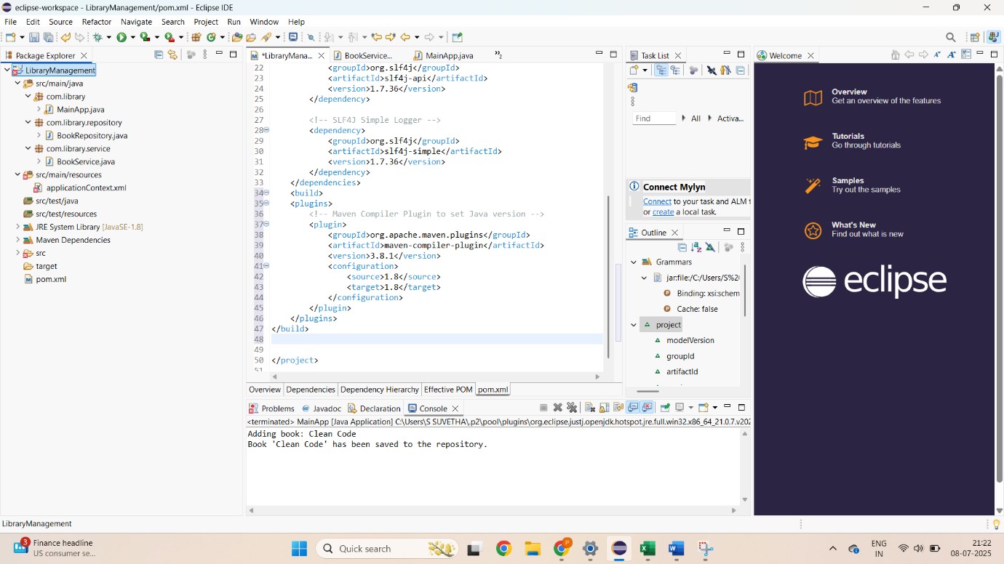

**Exercise 3: Implementing Logging with Spring AOP**

**Code:**

**BookService.java:**

package com.library.service;

import com.library.repository.BookRepository;

public class BookService {

    private BookRepository bookRepository;

    public void setBookRepository(BookRepository bookRepository) {

        this.bookRepository = bookRepository;

    }

    public void addBook() {

        System.out.println("Adding book...");

        bookRepository.save();

    }

}

**BookRepository.java:**

package com.library.repository;

public class BookRepository {

    public void save() {

        System.out.println("Book saved to database.");

    }

}

**MainApp.java:**

package com.library;

import org.springframework.context.ApplicationContext;

import org.springframework.context.support.ClassPathXmlApplicationContext;

import com.library.service.BookService;

public class MainApp {

    public static void main(String[] args) {

        ApplicationContext context = new ClassPathXmlApplicationContext("applicationContext.xml");

        BookService bookService = context.getBean("bookService", BookService.class);

        bookService.addBook(“Clean code);

    }

}

**LoggingAspect.java:**

package com.library.aspect;

import org.aspectj.lang.ProceedingJoinPoint;

import org.aspectj.lang.annotation.Around;

import org.aspectj.lang.annotation.Aspect;

@Aspect

public class LoggingAspect {

    @Around("execution(* com.library.service.*.*(..))")

    public Object logExecutionTime(ProceedingJoinPoint joinPoint) throws Throwable {

        long start = System.currentTimeMillis();

        Object result = joinPoint.proceed();

        long end = System.currentTimeMillis();

        System.out.println(joinPoint.getSignature() + " executed in " + (end - start) + " ms");

        return result;

    }

}

**Output:**

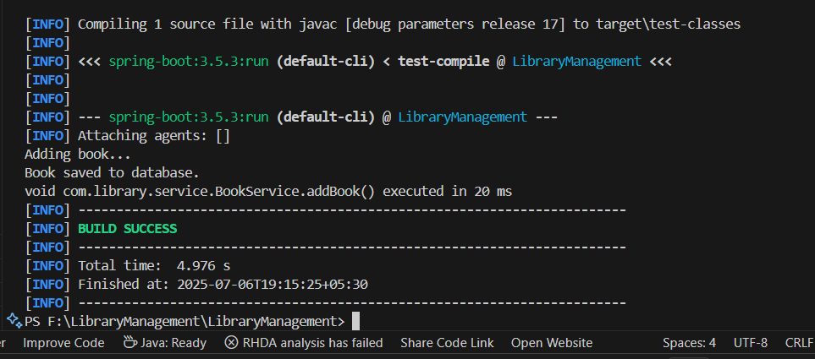

**Exercise 4: Creating and Configuring a Maven Project**

**Code:**

**pom.xml:**

<project xmlns="http://maven.apache.org/POM/4.0.0"

xmlns:xsi="http://www.w3.org/2001/XMLSchema-instance"

xsi:schemaLocation="http://maven.apache.org/POM/4.0.0 https://maven.apache.org/xsd/maven-4.0.0.xsd">

<modelVersion>4.0.0</modelVersion>

<groupId>com.library</groupId>

<artifactId>LibraryManagement</artifactId>

<version>1.0-SNAPSHOT</version>

<packaging>jar</packaging>

<properties>

<maven.compiler.source>1.8</maven.compiler.source>

<maven.compiler.target>1.8</maven.compiler.target>

</properties>

<dependencies>

<dependency>

<groupId>org.springframework</groupId>

<artifactId>spring-context</artifactId>

<version>5.3.34</version>

</dependency>

<dependency>

<groupId>org.springframework</groupId>

<artifactId>spring-webmvc</artifactId>

<version>5.3.34</version>

</dependency>

<dependency>

<groupId>org.springframework</groupId>

<artifactId>spring-aspects</artifactId>

<version>5.3.34</version>

</dependency>

<dependency>

<groupId>org.aspectj</groupId>

<artifactId>aspectjweaver</artifactId>

<version>1.9.21</version>

</dependency>

</dependencies>

<build>

<plugins>

<plugin>

<groupId>org.apache.maven.plugins</groupId>

<artifactId>maven-compiler-plugin</artifactId>

<version>3.8.1</version>

<configuration>

<source>1.8</source>

<target>1.8</target>

</configuration>

</plugin>

</plugins>

</build>

</project>

**BookService.java:**

package com.library.service;

import com.library.repository.BookRepository;

public class BookService {

    private BookRepository bookRepository;

    public void setBookRepository(BookRepository bookRepository) {

        this.bookRepository = bookRepository;

    }

    public void addBook() {

        System.out.println("Adding book...");

        bookRepository.save();

    }

}

**BookRepository.java:**

package com.library.repository;

public class BookRepository {

    public void save() {

        System.out.println("Book saved to database.");

    }

}

**MainApp.java:**

package com.library;

import org.springframework.context.ApplicationContext;

import org.springframework.context.support.ClassPathXmlApplicationContext;

import com.library.service.BookService;

public class MainApp {

    public static void main(String[] args) {

        ApplicationContext context = new ClassPathXmlApplicationContext("applicationContext.xml");

        BookService bookService = context.getBean("bookService", BookService.class);

        bookService.addBook(“Clean Code”);

    }

}

**LoggingAspect.java:**

package com.library.aspect;

import org.aspectj.lang.ProceedingJoinPoint;

import org.aspectj.lang.annotation.Around;

import org.aspectj.lang.annotation.Aspect;

@Aspect

public class LoggingAspect {

    @Around("execution(* com.library.service.*.*(..))")

    public Object logExecutionTime(ProceedingJoinPoint joinPoint) throws Throwable {

        long start = System.currentTimeMillis();

        Object result = joinPoint.proceed();

        long end = System.currentTimeMillis();

        System.out.println(joinPoint.getSignature() + " executed in " + (end - start) + " ms");

        return result;

    }

}

**Output:**

